English – Body Idioms

- to give somebody a hand to help somebody
- to put your foot in it to say something inappropriate
- to pull somebody’s leg to joke with somebody (not offensive)
- to be on the tip of your tongue to have difficulty to remember something
- to have cold feet to be nervous about something
- to have butterflies in your stomach to be worried about something
- to break somebody’s heart to hurt your partner emotionally
- can’t get a song out of your head can’t stop thinking about a song
- to know by heart to know something by memory
- to get something off your chest to share a problem


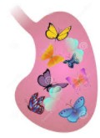
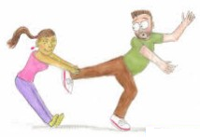

Exercise:
leg stomach heart chest hand

tongue feet heart head foot

1. You’re pulling my ____________! You can’t be serious!

2. I can’t get that Katy Perry song out of my ____________!

3. Could you give me a ____________ with my homework?

4. You really put your ____________ in it when you told Peter that Jane likes him!

5. The test is on Friday – I have butterflies in my ____________.

6. I can’t remember his name – it’s on the tip of my ____________.

7. Jim doesn’t know if he should marry Eliza, he has cold ____________.

8. My son knows all the names of the dinosaurs by ____________.

9. When Susan broke up with Dave, she broke his ____________.

10. Can we talk? I need to get something off my ____________.
Here are some more body idioms/expressions:

- to head a committee
- to eye somebody
- to nose around
- to mouth the words
- to jaw at somebody
- to neck in the cinema
- to shoulder the weight
- to elbow your way in
- to hand somebody something
- to finger somebody
- to knuckle under
- to thumb a lift
- to stomach something
- to rib somebody
- to knee somebody
- to leg it to somewhere
- to heel on command
- to foot the bill
- to toe the line

